
SCHOOL OF COMPUTING AND ENGINEERING SCIENCES (SCES)
BACHELOR OF SCIENCE IN ELECTRICAL AND ELECTRONICS ENGINEERING (BSEEE)
CIRCUIT THEORY EXPERIMENT ON DC TRANSIENTS
BY:
Mwongela Edward Aribu - 142092
COLLABORATORS:
Shanice Mwenda Kendi - 145709
Abigail Wangechi Ndegwa – 145527

ABSTRACT
This is a report that contains the data obtained in a laboratory experiment conducted in the Strathmore engineering laboratories by the group 11 on

Table of Contents
ABSTRACT 2
INTRODUCTION 4
TABLE OF FIGURES 5
OBJECTIVES AND EXPECTED OUTCOMES 6
CIRCUIT DIAGRAMS, THEORETICAL ANALYSES, SAMPLE CALCULATIONS AND SIMULATIONS 7
MATERIALS, APPARATUS, METHODOLOGY AND TABLES 9
EXPERIMENTAL SETUP, RESULTS AND GRAPHS 10
VIDEO UPLOAD 12
REFERENCES 13

INTRODUCTION

TABLE OF FIGURES
Figure 1 7
Figure 2 7
Figure 3 8
Figure 4 8
Figure 5 11
Figure 6 11
Figure 7 12
Figure 8 12

OBJECTIVES AND EXPECTED OUTCOMES
The project requires the development of a system that will control the on/off timing on a set five (5) LED traffic signal lights at a one-way pedestrian crossing as shown in the figure below. The request to stop the vehicle for the pedestrian(s) to cross is generated from a pushbutton. (To earn bonus marks, the pushbutton control can be implemented on a mobile phone application installed on a pedestrian phone). The student is required to design a system and write the appropriate microcontroller code using the hardware described in the document.

CIRCUIT DIAGRAMS, THEORETICAL ANALYSES, SAMPLE CALCULATIONS AND SIMULATIONS

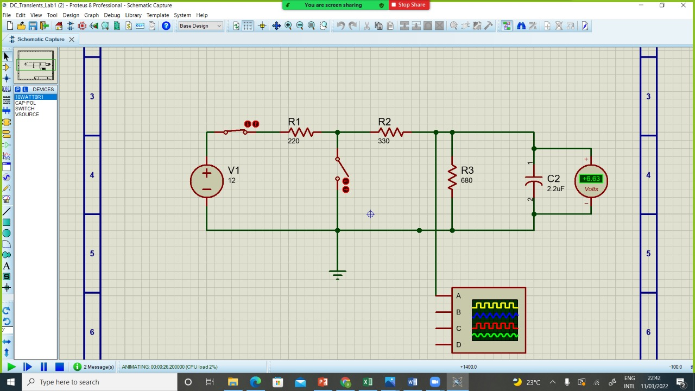
Figure 1
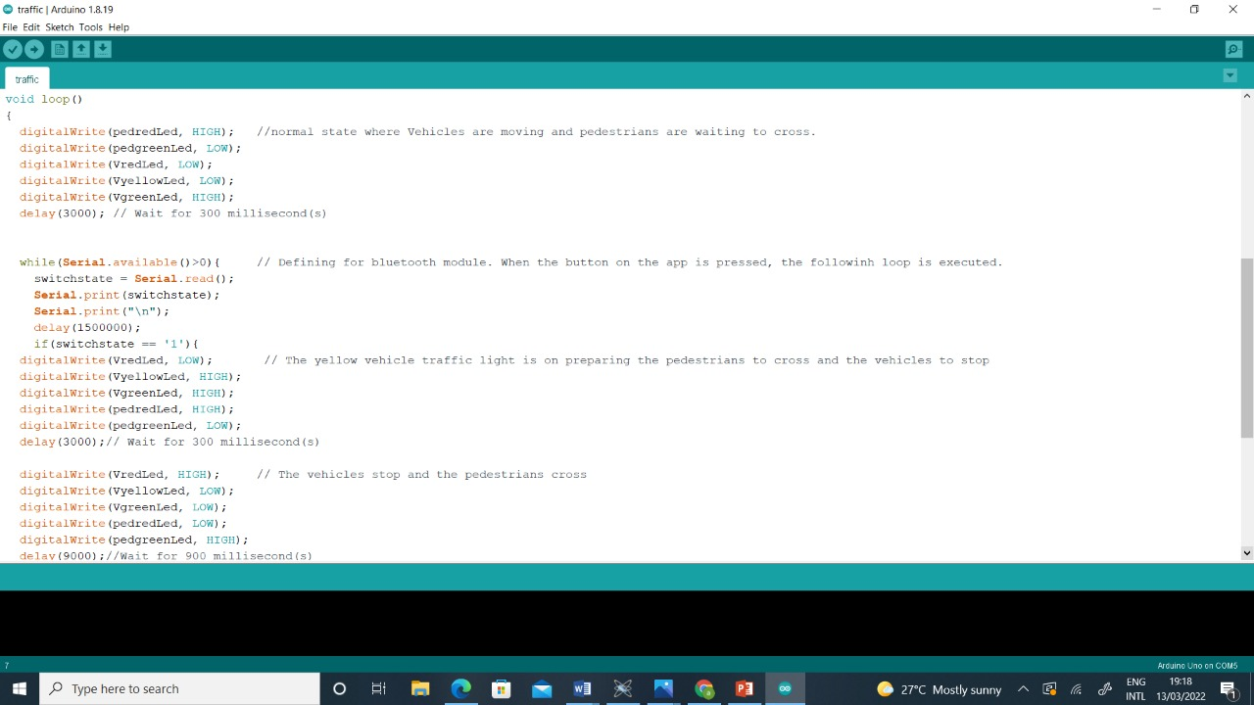
Figure 2

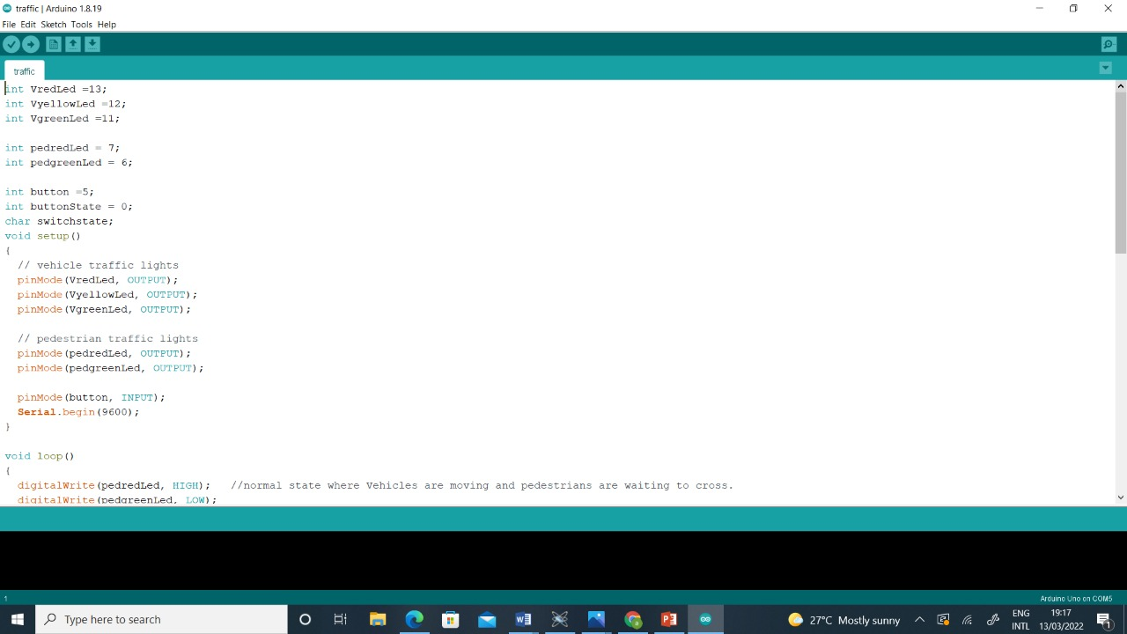
Figure 3

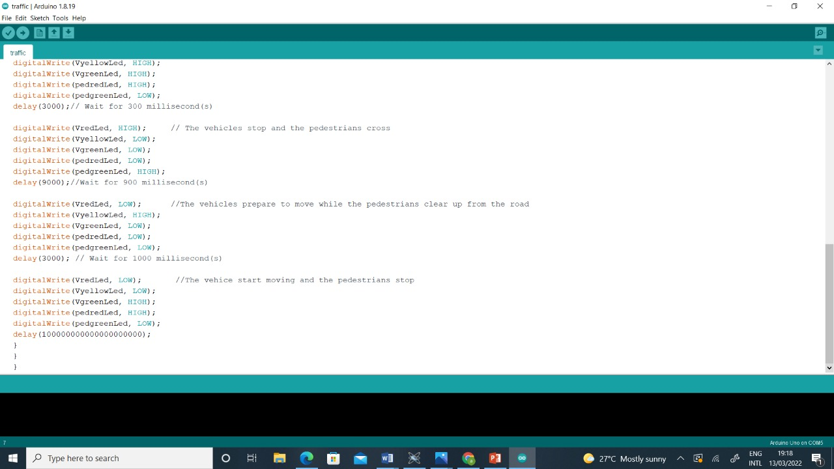
Figure 4

MATERIALS, APPARATUS, METHODOLOGY AND TABLES

Apparatus
Two green LEDs
Two red LEDs
One orange LED
Jumper wire
Bluetooth microcontroller
Breadboard
Arduino uno
Five resistors

EXPERIMENTAL SETUP, RESULTS AND GRAPHS

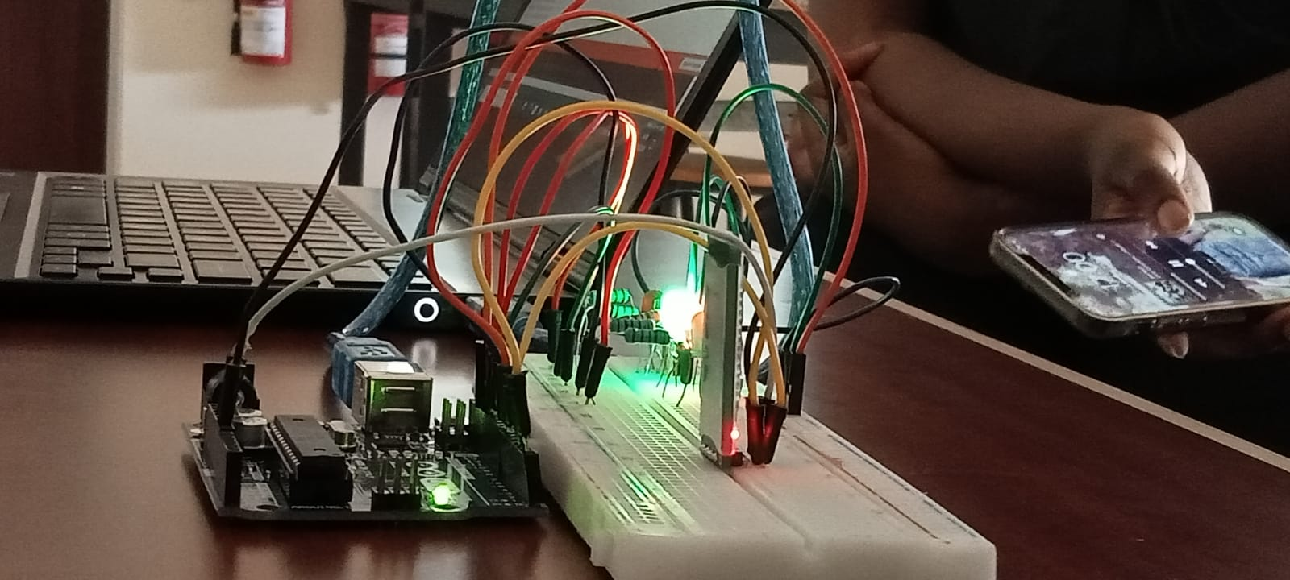
Figure 5

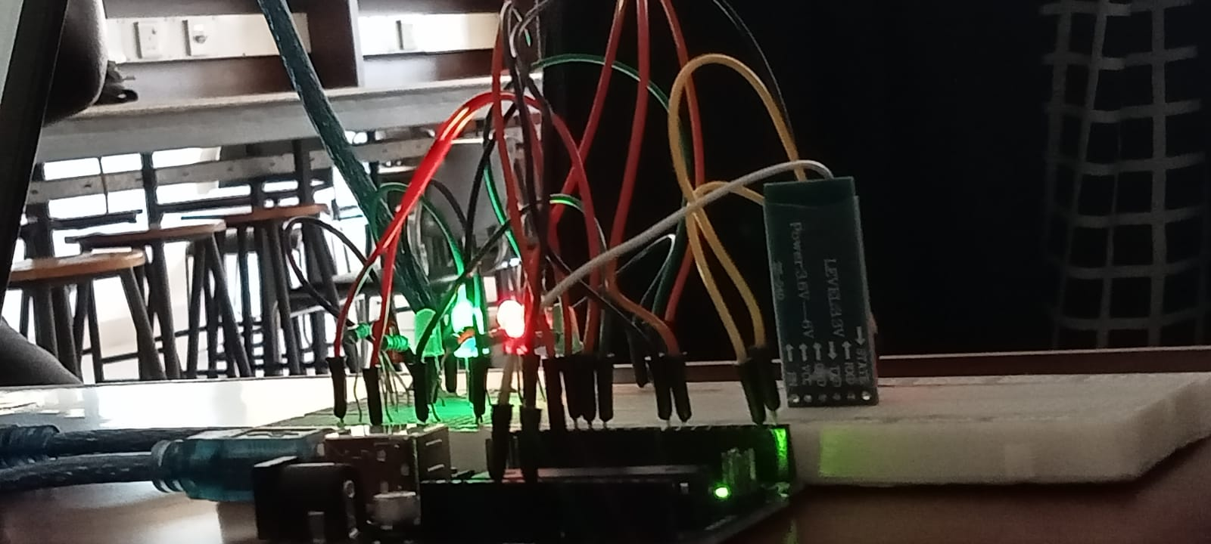
Figure 6

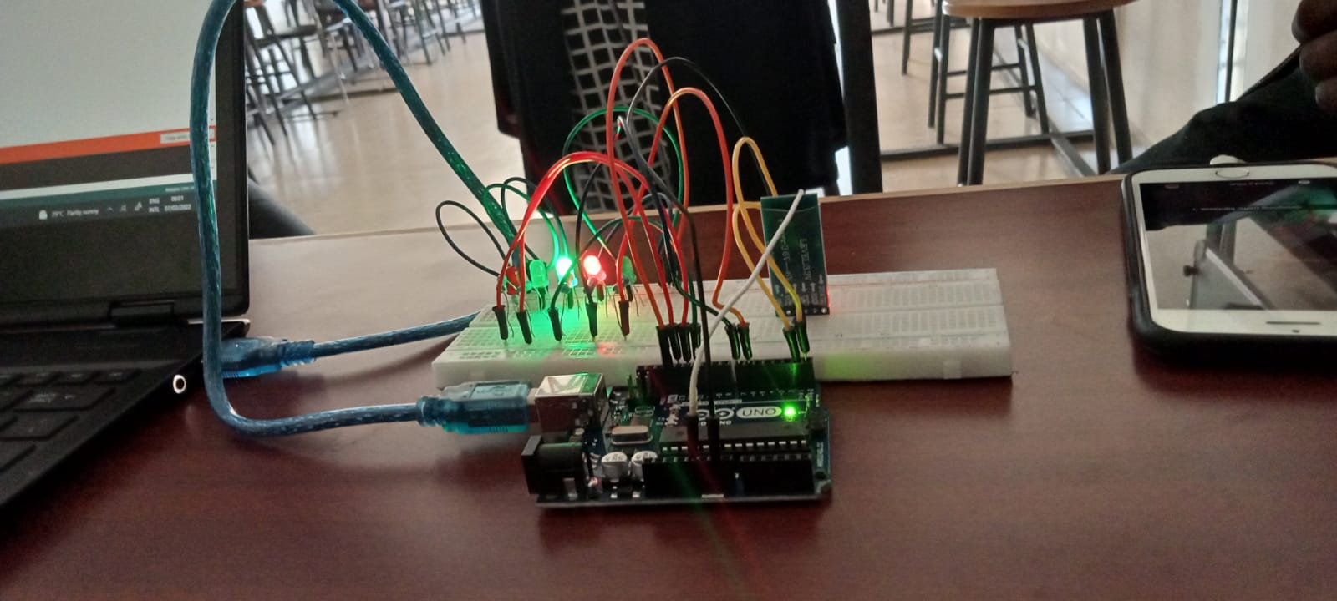
Figure 7

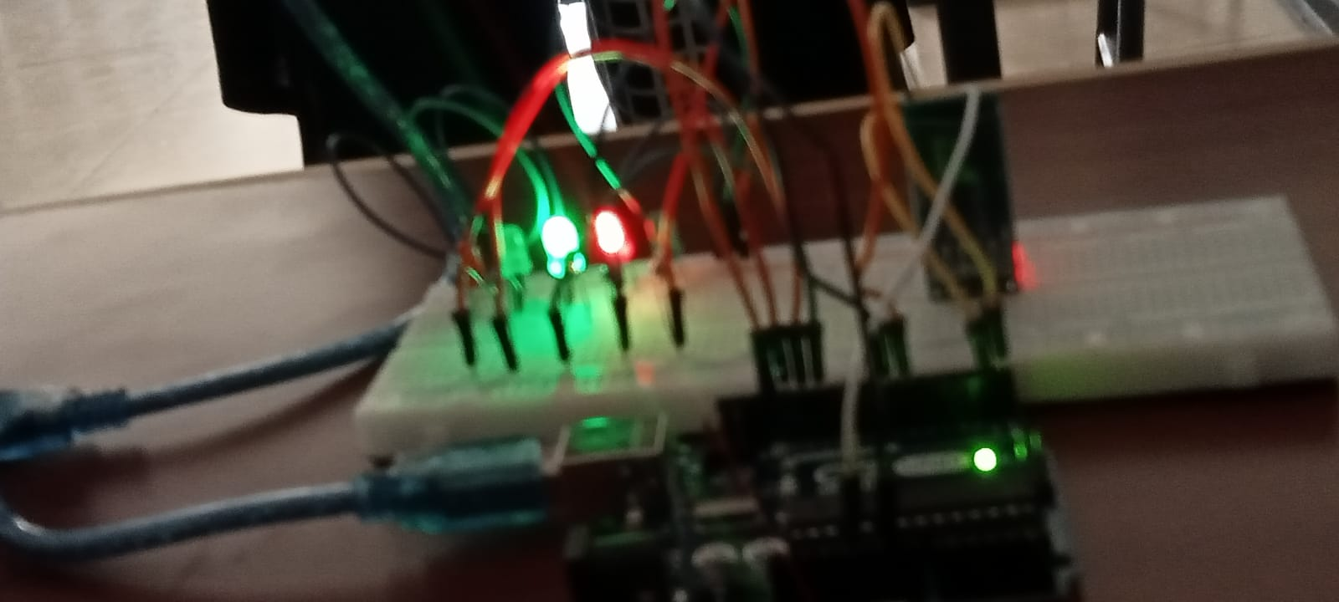
Figure 8

VIDEO UPLOAD
https://drive.google.com/drive/folders/1HYlQarNsZNC85rRpcBWeWMEWm0A8Zd2I

REFERENCES

